Wireless Communications: Communications Link

Gian Angelo Tria   
*Electrical Engineering*  
*The Cooper Union*NY, United States of America  
tria@cooper.edu

*Abstract*— The goal was to design and simulate a communications link. This communications link met specific BER (bit error rate) requirements as well as attempted to maximize the total number bit rate. Basic Binary modulation through an AWGN channel was done first. Then, Linear modulation schemes were used in combination with BCH encoding and Linear RLS (Recursive Least Squares) Equalization in order to bring the BER down to the magnitude of 10-6 and a bit rate of .7540 with the most recent simulation.

# Part 1: QAM, BPSK and Adaptive Equalization

First, random bits of value +- 1 were used as test data. This was converted to an M-ary number by creating a function. It was then BSPK modulated and passed through a moderate ISI channel. The resulting signal was then demodulated and converted back to binary in order to compare BER for a given SNR. This was done for the M values of 2,4, and 16 as seen in Figures 1,2, and 3 respectively.

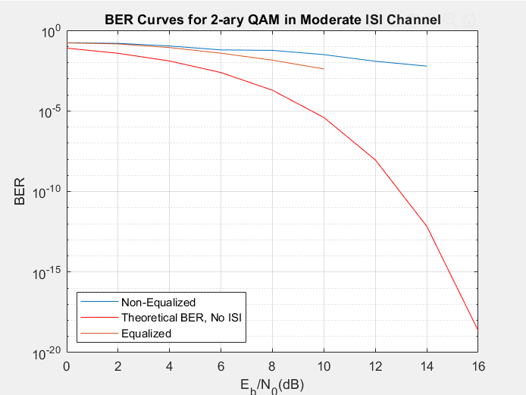

Fig 1: BER Curves for 2-ary QAM

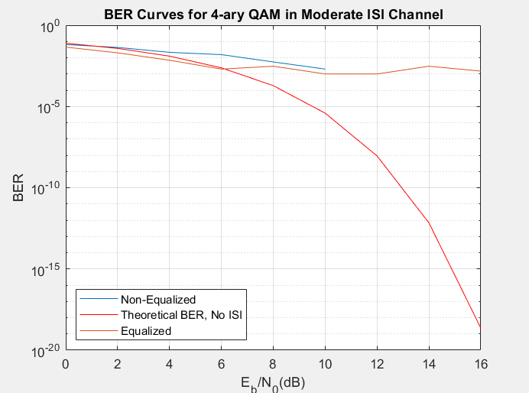

Fig 2: BER Curves for 4-ary QAM

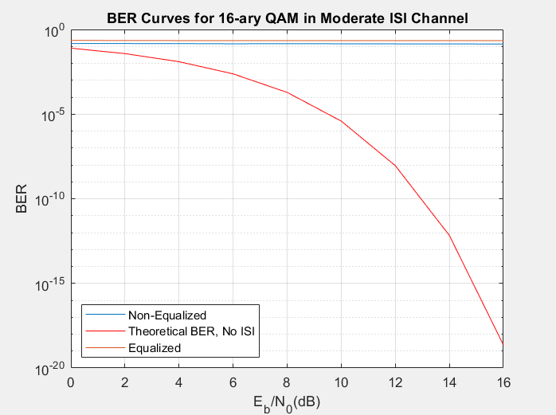

Fig 3: BER Curves for 16-ary QAM

Performance of the equalized signal is best with 4-ary QAM with the BER of 2 and 16-ary QAM being higher than the 4-ary QAM at the desired SNR of 12.

# Minimizing BER and Maximizing Bit Rate

In order to minimize the BER while maximizing the bit rate, BCH convolutional encoding was used to encode and decode. Different codeword and message lengths were experimented with to see which code achieve the intended BER of 10-6 while maximizing the bit rate. This corresponded with affecting other parameters for the BCH encoder such as the number of training bits.

The random bits were generated to with respect to the convolutional code and then passed through a noisy AWGN channel before equalizing with a differential feedback equalizer. Linear equalization proved to not be effective enough.

After equalization, the code was decoded and the BER was calculated along with the bit rate. The resulting bit rate was .7540 with a BER of 3x10-6.